Module 3.1

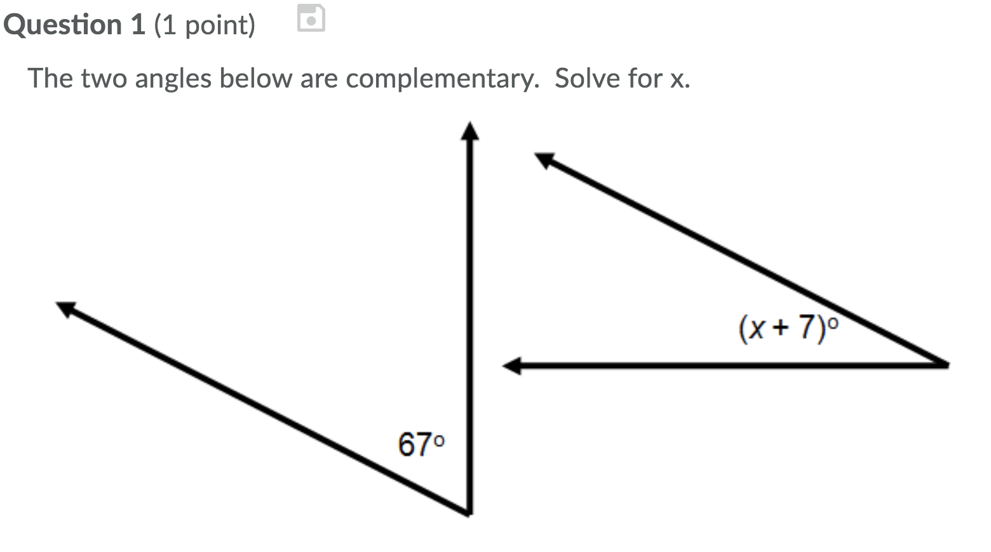

Solution
67 + x + 7 = 90
X = 90-74 = 16⁰
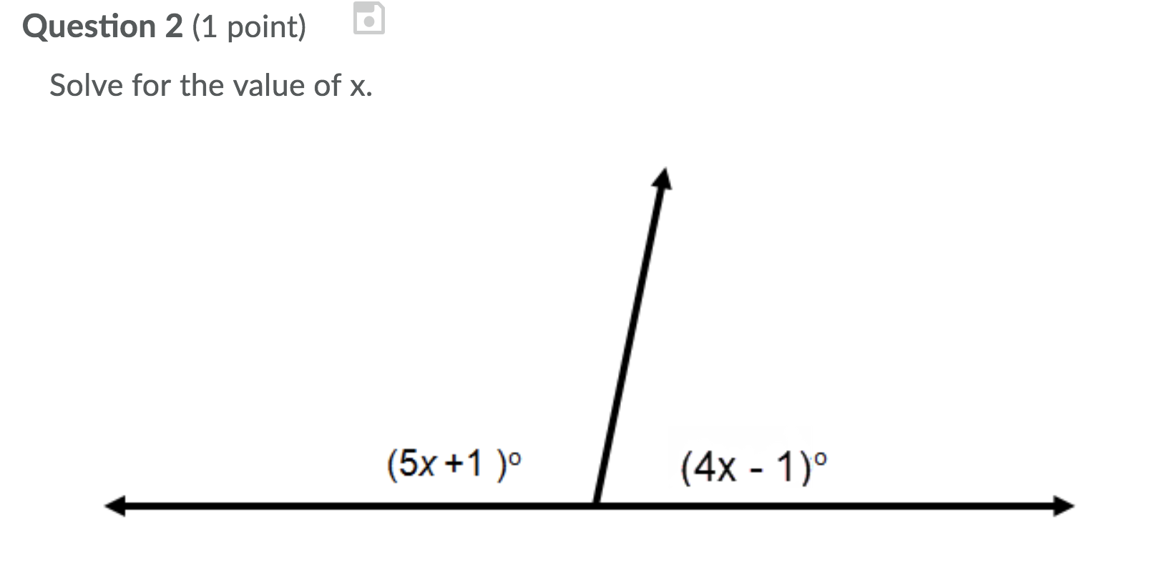
Solution
5x+1+4x – 1 = 180
9x = 180
X = 20⁰
s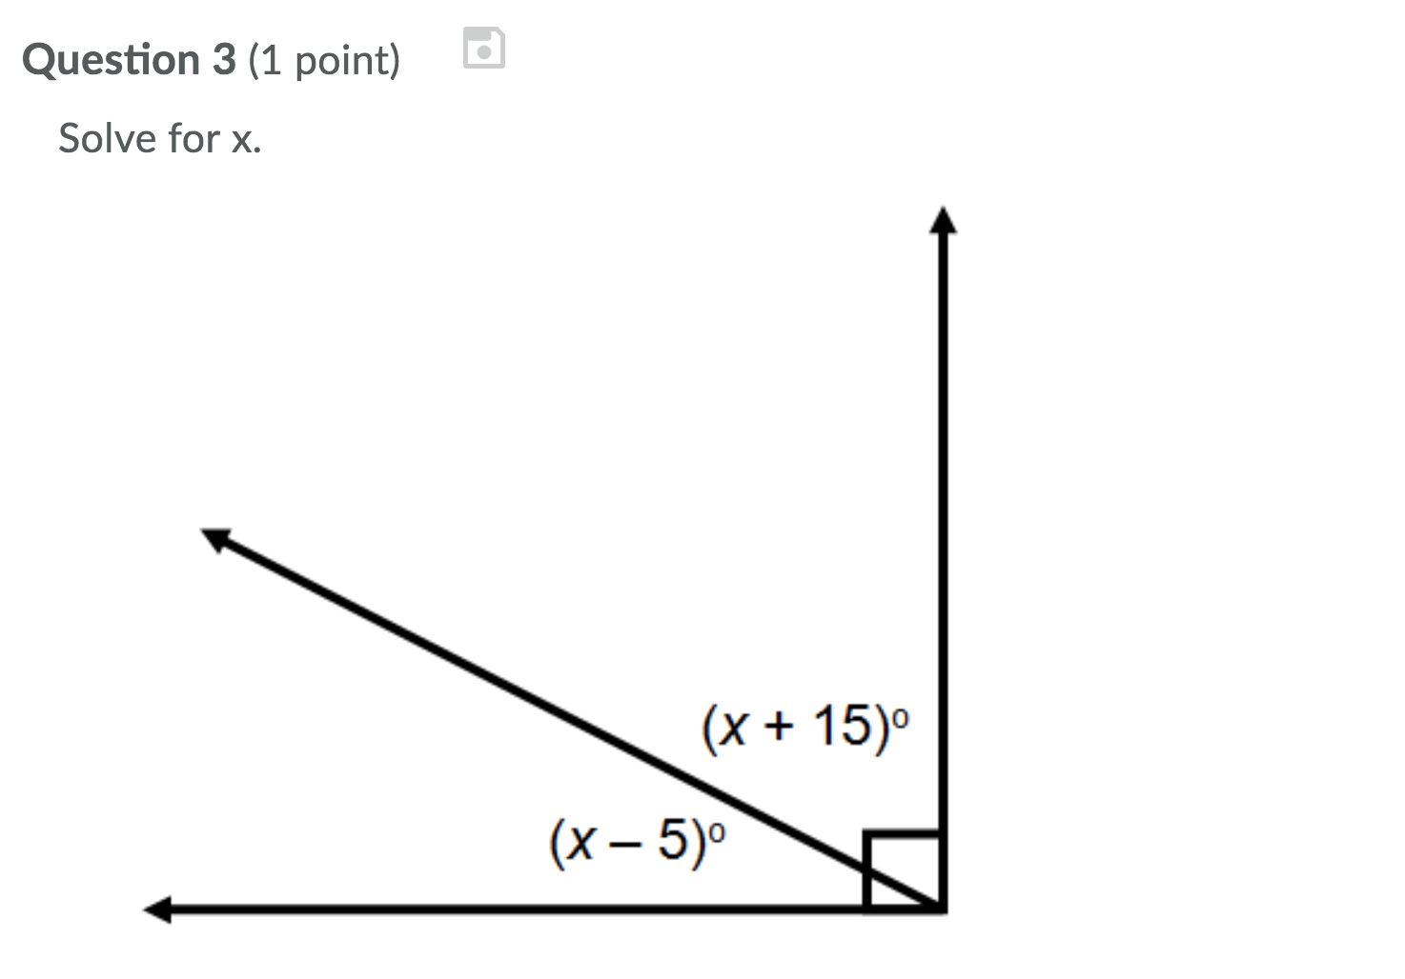
Solution
X – 5+ X + 15 = 90
2X + 10 = 90
2X = 90-10
2X = 80
X = 40⁰

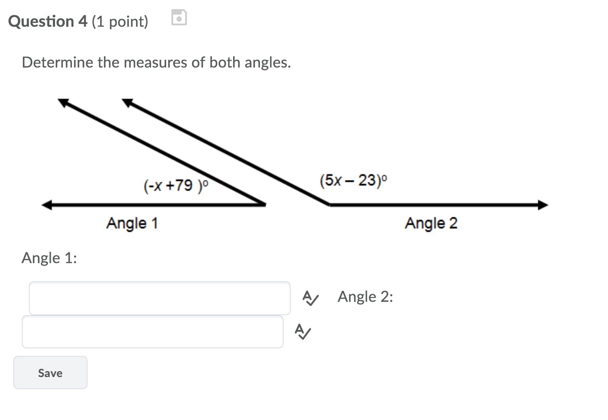

Solution
-x +79+5x -23 = 180
4x + 56 = 180
4X = 180 – 56
4x = 124
X = 31⁰
Angle 1 = -31 + 79 = 48⁰
Angle 2 = 5(31) – 23
155 – 23 = 132⁰

Module 3.2

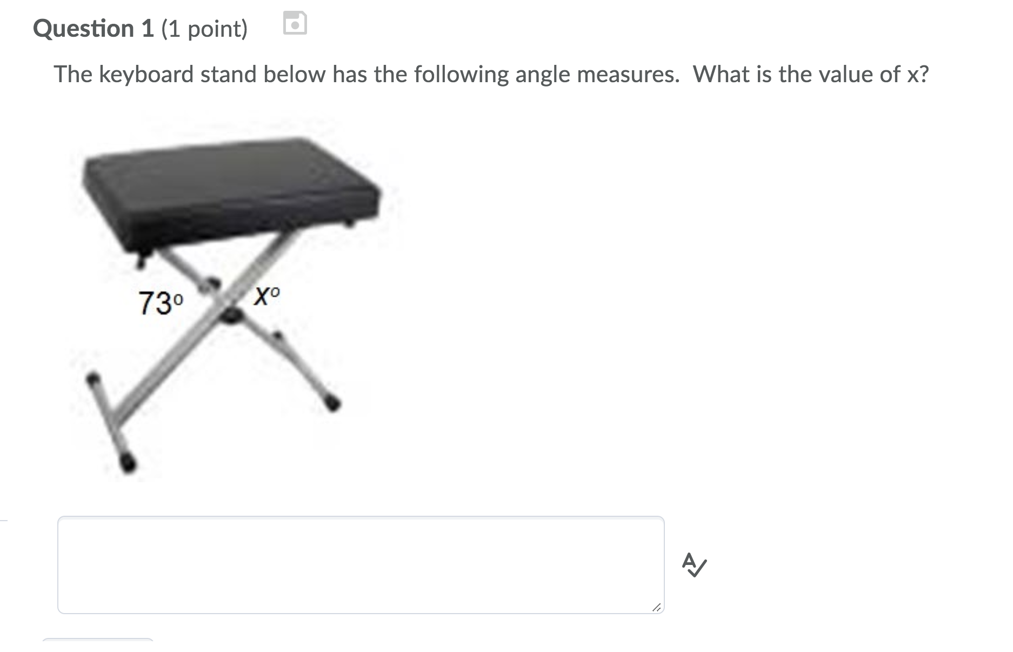

X = 107⁰
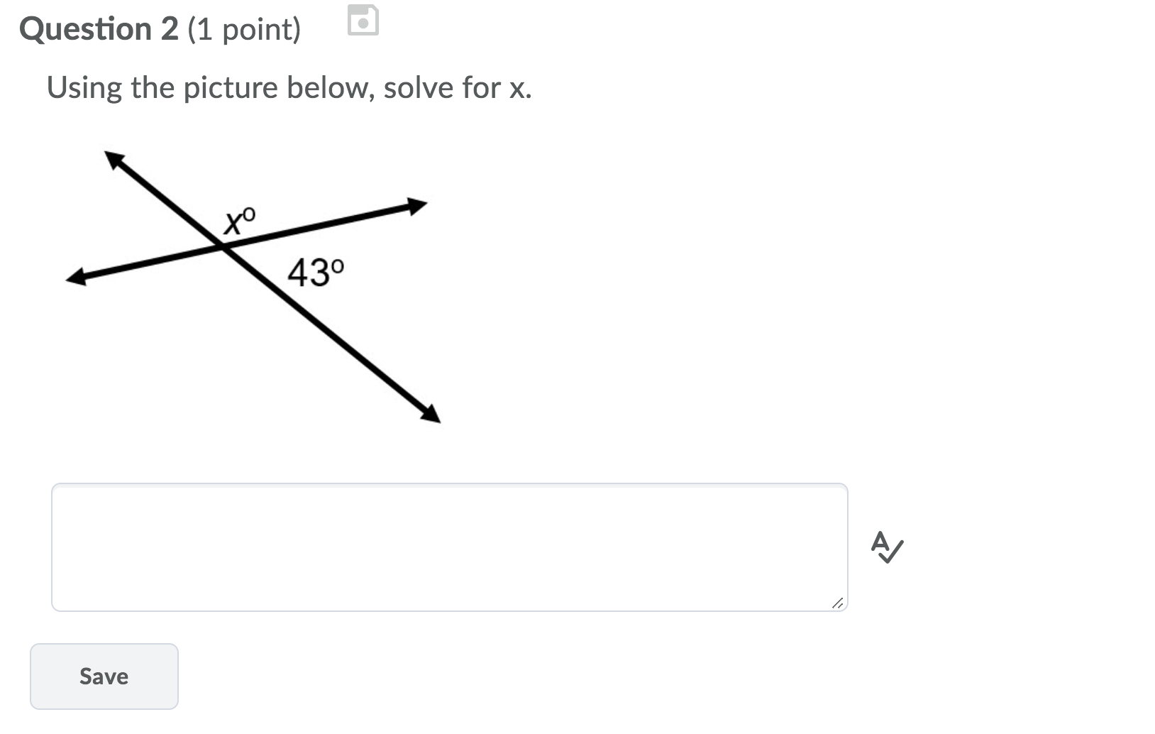
X = 137⁰
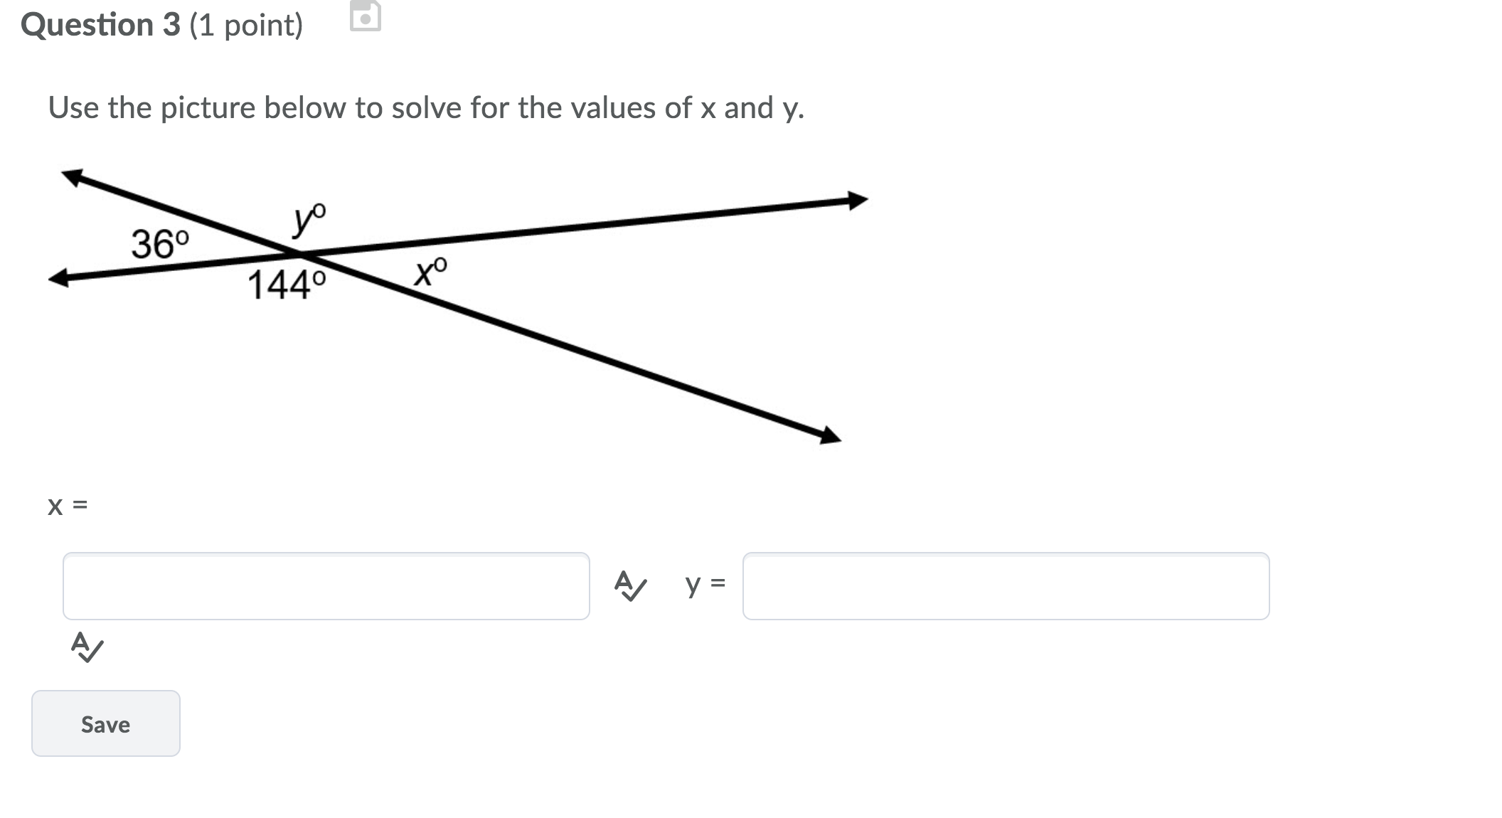
X = 36⁰
Y = 144⁰
Module 3.3

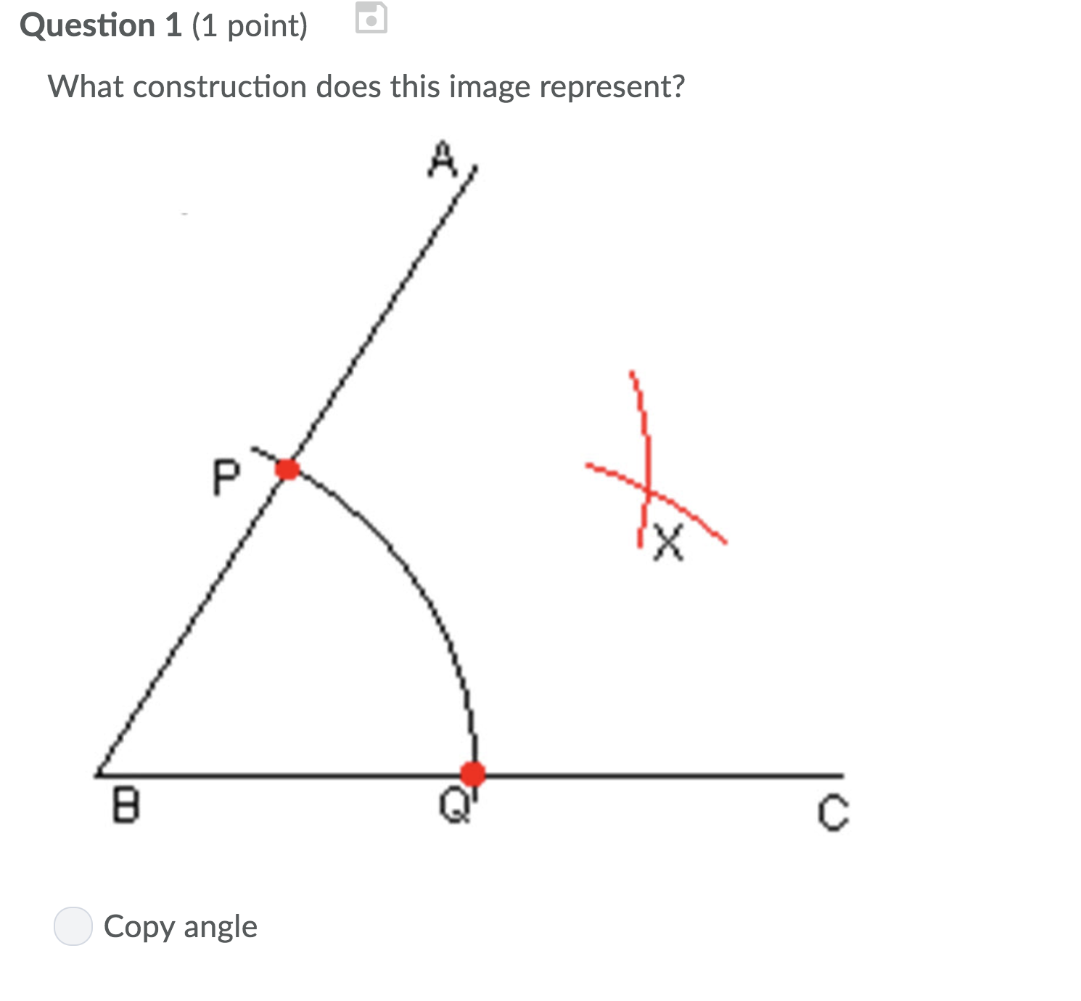


Angle bisector
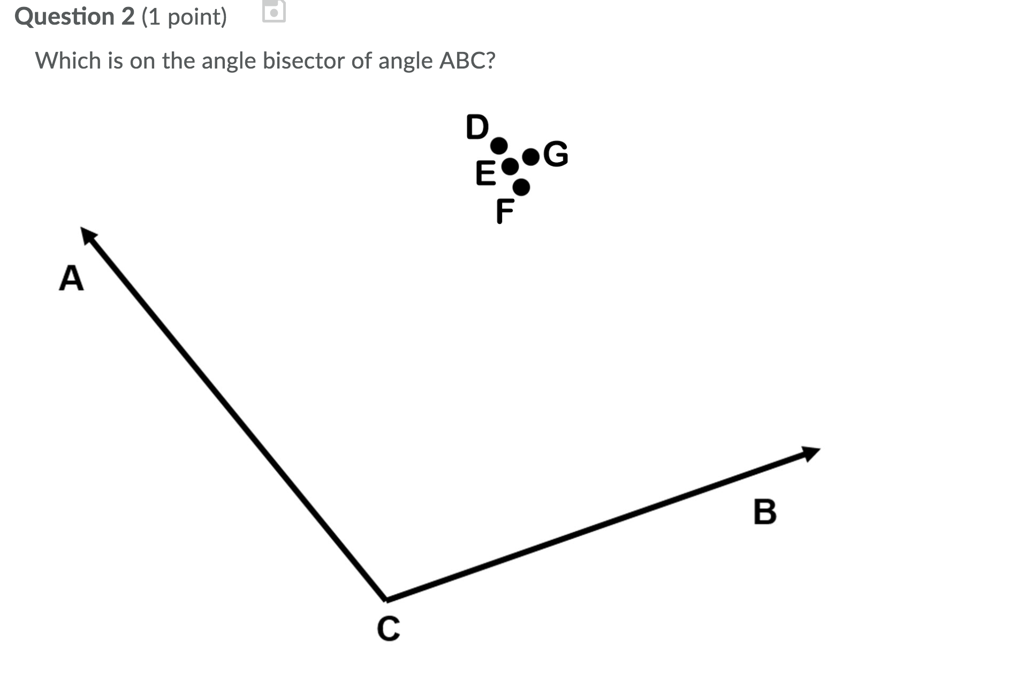

E
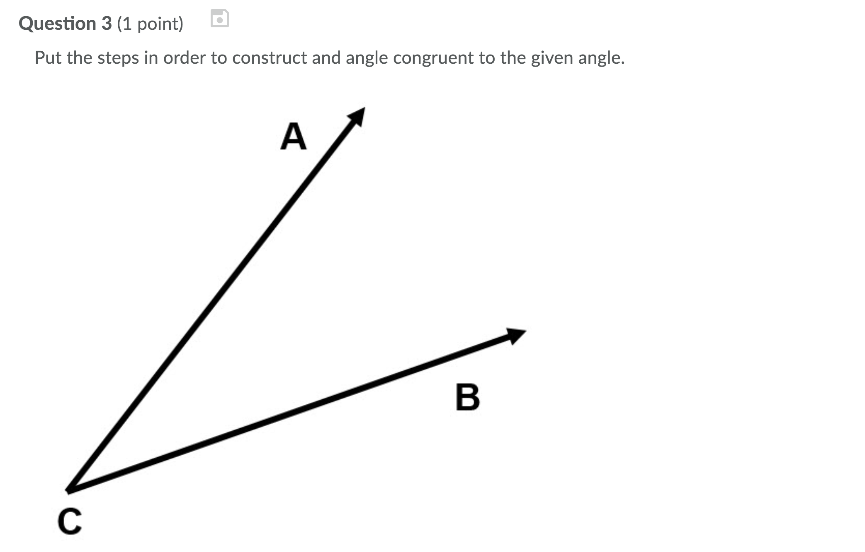

Number 1 -6

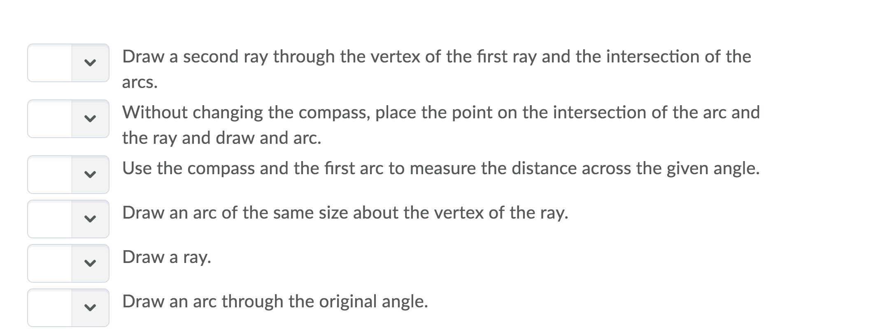

The steps are 5>6>4>3>2>1

